ANNUAL
REPORT
(JULY 2022 - JUNE 2023)


mictmanagement@gmail.com
+92-51-8468650

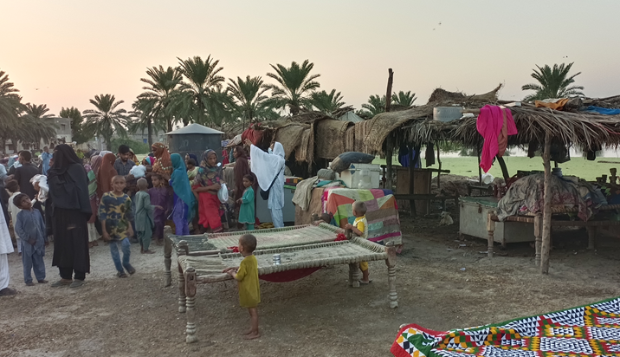

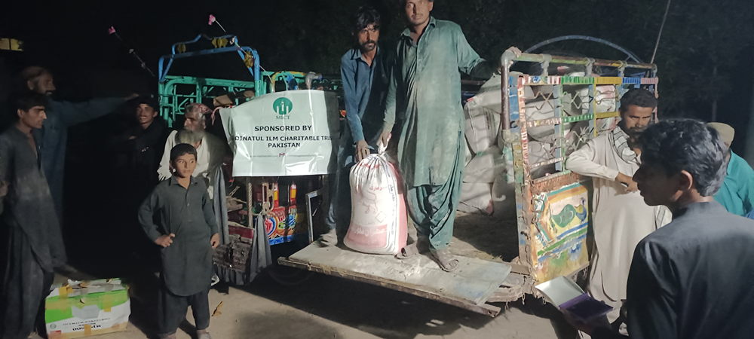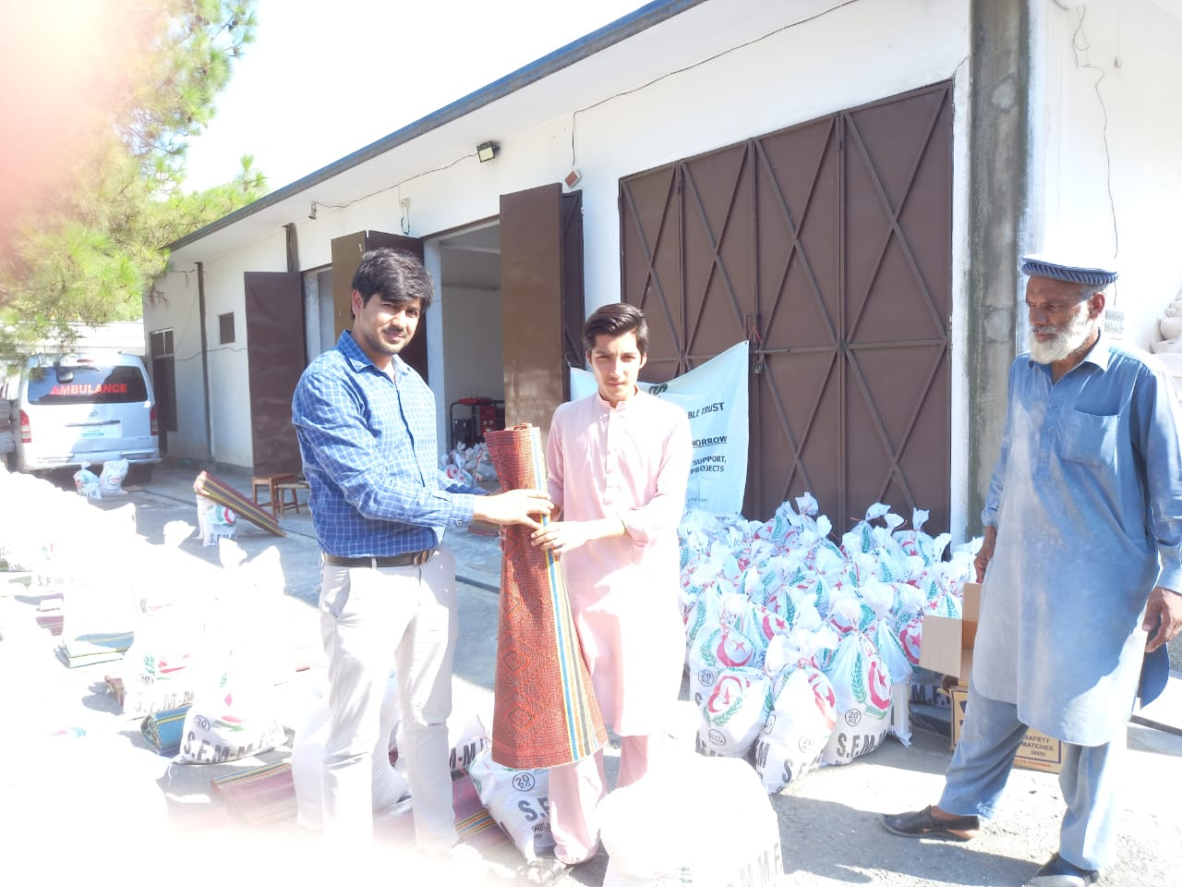

ANNUAL REPORT
HELPING PEOPLE – CHANGING LIVES
Introduction:
In Pakistan, 39.6% (source; The World Bank) of people are living below the poverty line, indicating a profound need for immediate action to help bring an end to this situation. We believe that every human being has the right to live a life of self-respect, dignity and economic security. While Madinatul Ilm charitable trust (MICT) is committed to a variety of avenues for helping those in need, our ultimate objective is to tackle the fallout from poverty. Millions of people were affected by floods and required life-saving assistance. Climate change is increasing the frequency and scale of disasters such as those related to floods and heavy rains. In view of this, MICT stepped up relief operations, working across Pakistan through food support, health, clothes, livelihood and emergency relief.
The MICT’s core objectives are:
- Empowering those in need while simultaneously sensitizing our supporters to the challenges faced by the less fortunate members of our society.
- While we pursue multiple tracks to help our targeted populations, our ultimate objective is to enable our beneficiaries to pursue the best possible education for themselves and their dependents.
- We are dedicated to help communities in crisis hit situations, enabling them to return to lives of normalcy.
- While education remains our prime objective, overcoming other obstacles to human well-being such as unemployment and water-shortage in far flung areas, are also of central interest to our work.
OUR WORK AT A GLANCE
Here are the areas supported by MICT in 2022-2023:

- Education Program:
MICT provided support to formal education regardless of age, gender, grade or location. During the reporting period MICT spent Rs 1,362,439 to support 13 students in different grades and fields of study.

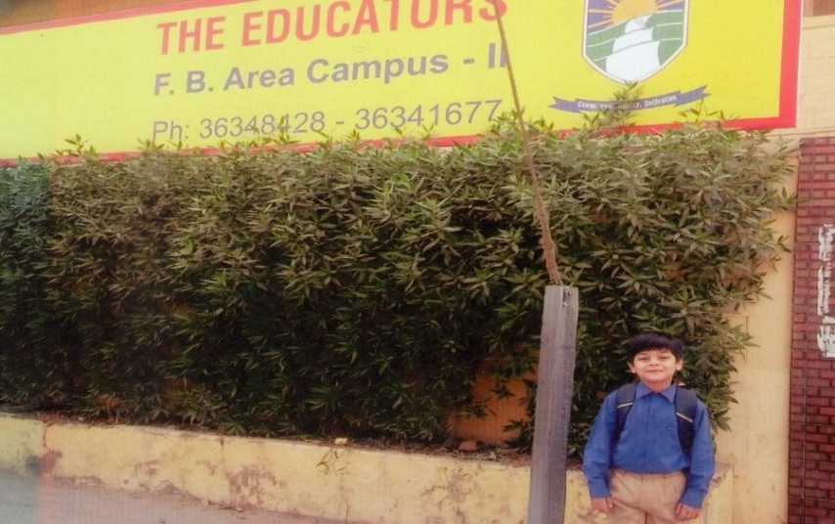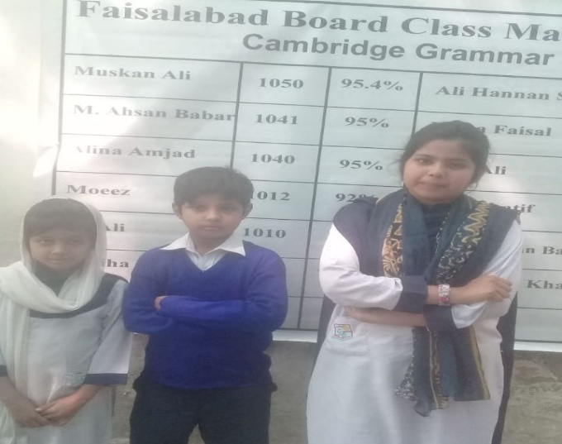

- Health Program:
MICT disbursed Rs. 1,439,939 to five patients in need of financial assistance. Cancer patients, hearing disorder patients and autism disorder patients were treated during the period under review.
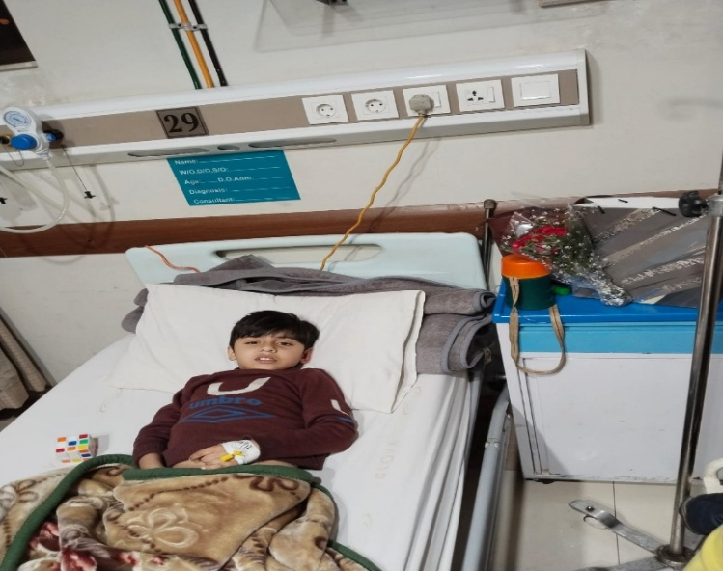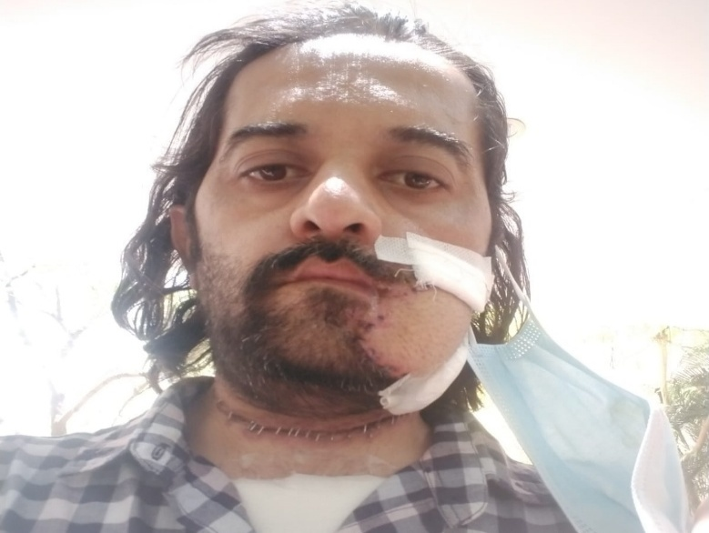

- Water & Sanitation Program:
Rs. 1,797,000 were spent in different water scarce areas of District Muzaffargarh, Jhang, Skardu, Khair Pur Mirs, Chakwal and Sukkur on the installation of 38 hand pumps. One hand pump was installed in a BHU in Islamabad Capital Territory. Partnerships were experienced with government and non-government entities.
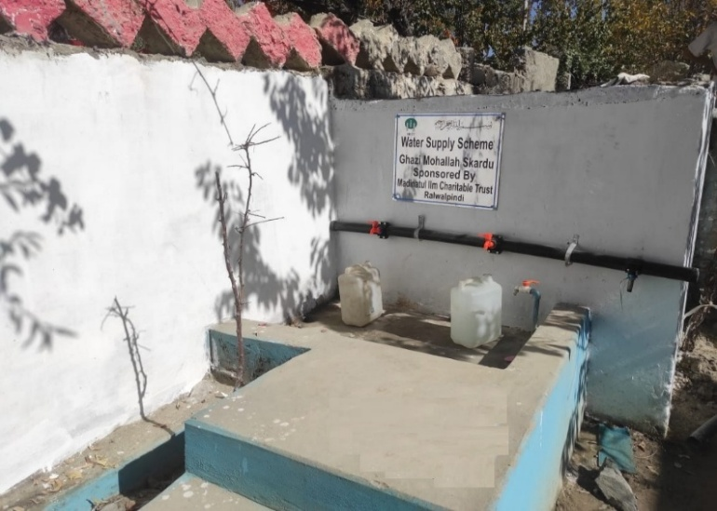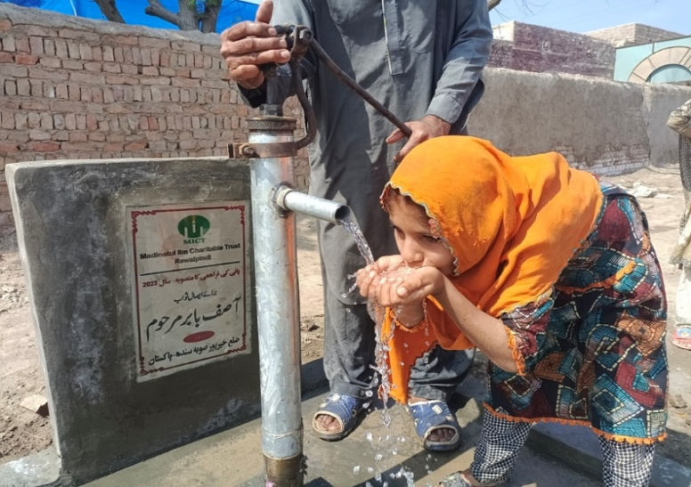

- Ramzan Food Program:
Ramzan food packs were delivered to 473 families in Rawalpindi and Khair Pur (Mirs) covering the approximately 2840 individuals. The total cost of these food packs were Rs. 1,952,445. This component was under achieved due to the separate increase in focus on food pack distribution in flood affected areas.
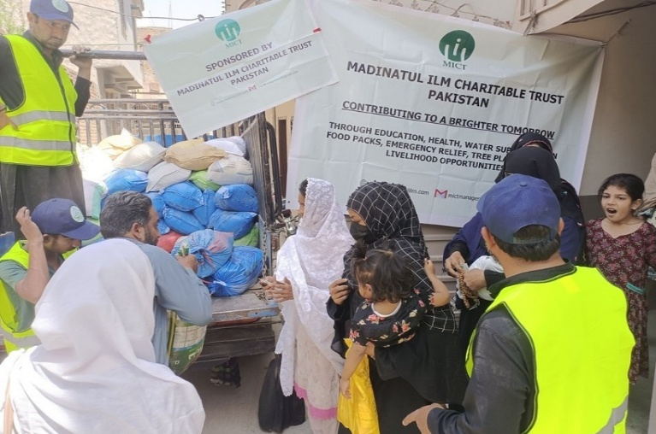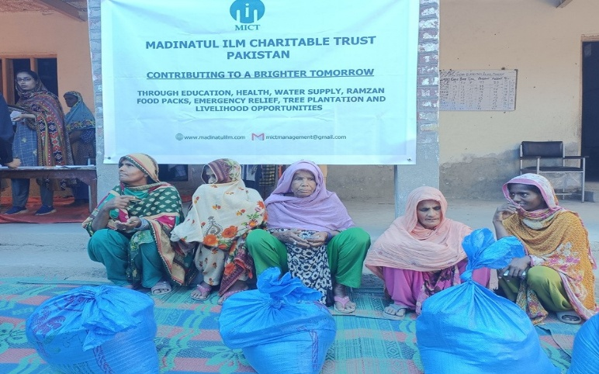

- Capacity Building & Livelihood Program:
MICT actively continued to search for impoverished individuals who were able and willing to use support for establishing businesses at the grass roots. One case of Livelihood was supported at the cost of Rs. 20,800 for a food business.
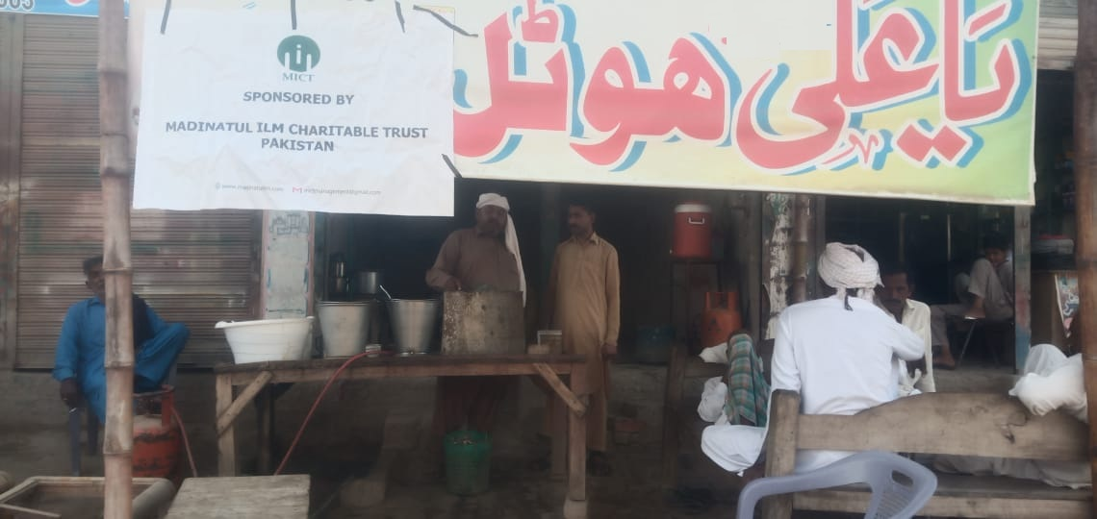
- Emergency Relief Program
Widespread floods across Pakistan caused unprecedented destruction in several parts of the country. In response to
this emergency MICT supported a wide range of activities all over in the country.
Food packs were delivered to 1279 families comprising at least 7700 individuals. The total cost of these food packs was Rs. 7,502,270.
MICT supported Indus Development Society (IDS) to rebuild a school in Badin though the use of Rs. 818,000.
MICT partnered with the Indus Resource Center (IRC) to distribute mosquito nets amongst flood affectees of Jamshoro (Sindh) worth Rs. 244,500.
MICT bought jackets and sweaters worth Rs. 176,450 and distributed them amongst flood affectees through
volunteers in Lasbela, Balochistan.
Under livelihood promotion, MICT partnered with the Institute for Development Studies and Practices (IDSP) to provide seeds worth Rs.800,000 for poor and small farmers in the five most flood affected districts of Balochistan.
Further, MICT provided Rs. 380,000 and medicines to IDSP to set up free medical camps in the affected districts of Balochistan and Sindh.
MICT supported the reconstruction of a widows’ house in a flood affected village in Muzaffarabad, AJK worth Rs. 173,600/-

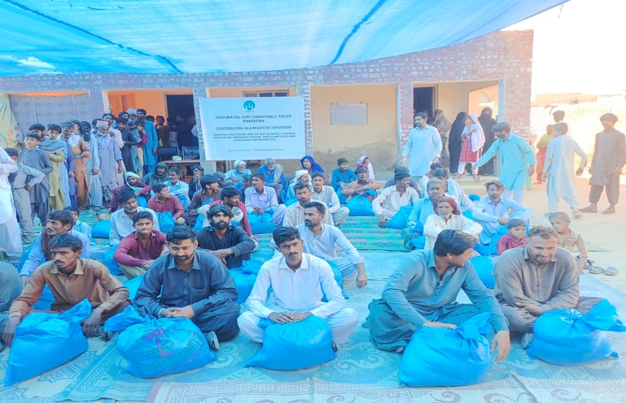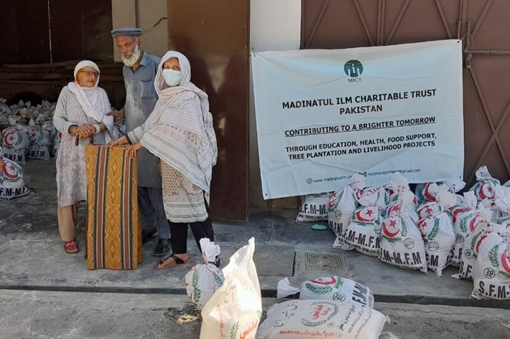
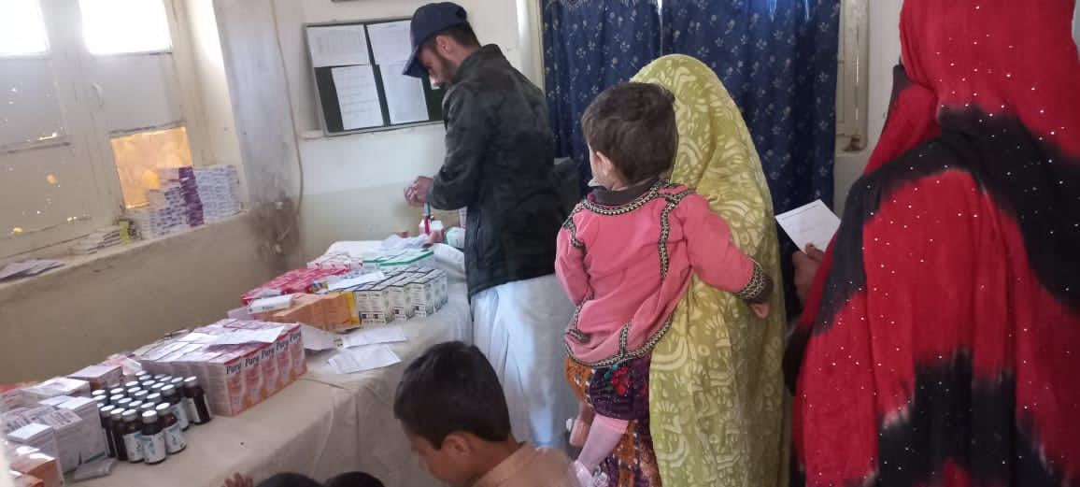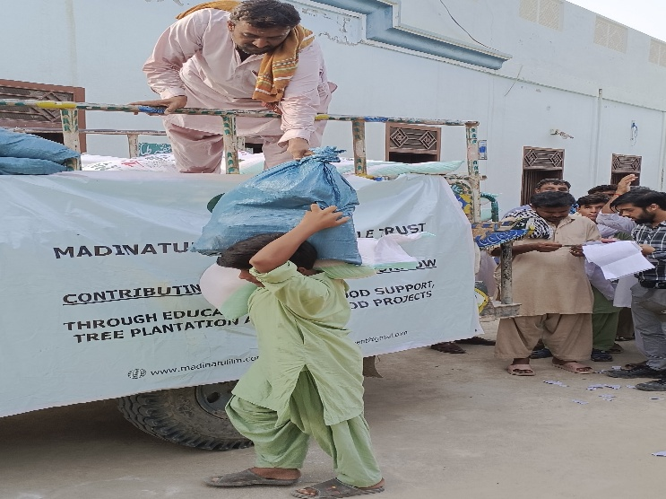

- Funds used by Program:

- Madinatul Ilm Charitable Trust condensed financial statement as of June 30, 2023:

Sr No | Particulars | (Rupees)
1 | Non-current Assets | 160,644,744
2 | Current Assets | 8,492,876
3 | Total Assets | 169,137,620
4 | Current Liabilities | 268,926
5 | Non-current Liabilities | 14,321,675
6 | Reserve Fund | 154,547,019
7 | Total Funds and Liabilities | 169,137,620

- Madinatul Ilm Charitable Trust condensed statement of income and expenditure for the year ended June 30, 2023:

Sr No | Particulars | (Rupees)
1 | Donations | 32,518,368
2 | Program Expenses | (16,668,363)  (4,097,398)
3 | Operating Expenses | (16,668,363)  (4,097,398)
4 | Total Expenses | (20,765,761)
5 | Donations less Expenses | 11,752,607
6 | Other Income | 1,936
7 | Surplus/(Deficit) for the year 2023 | 11,754,543

FUTURE PLANS
MICT remains dedicated to continuing its work for crisis-stricken communities across Pakistan. Please join us in achieving our objectives. Thank You!
This account cannot receive funds from a foreign currency account
BANK AL HABIB
Chaklala Scheme – III Branch Rawalpindi, Pakistan
Account No: 0061-0081-000620-016 / IBAN – PK52BAHL0061008100062001
MADINATUL ILM CHARITABLE TRUST
Address: Afshan Manzil, first floor, Plot 38, Mini Riverview, Commercial Mall, extension-II, Phase 7, Bahria Town, Rawalpindi
Email: mictmanagement@gmail.com

*****************************************************************************

